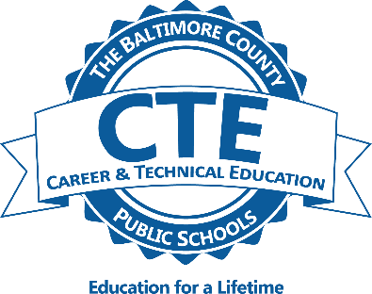
Teacher Academy of Maryland

The Teacher Academy of Maryland (TAM) completer program prepares students for postsecondary education and careers in the field of education. The program focuses on teaching as a profession, and includes information on human growth and development, learning theory, and curriculum and instruction. Students participate in internship experiences that include exposure to multiple age levels and subjects. Students who complete the program may earn articulated college credits.
Teaching as a Profession
Teaching as a Profession is a course designed to introduce high school students to the current, historical, philosophical, and social perspectives of American education, including trends and issues. Students are expected to critically examine their assumptions about teaching and learning and explore multiple perspectives in order to develop informed positions about contemporary issues in education.

Child and Adolescent Development
This course is designed to introduce high school students to the theories of physical, cognitive, and psychosocial development of school age children. Students explore the impact on education for those children who have special challenges to growth and development.

Foundations of Curriculum and Instruction (Prerequisite: Completion of preceding courses in pathway)
This course explores curriculum delivery models in response to the developmental needs of all children. Emphasis is placed on the development of varied instructional materials and activities to promote learning, classroom management strategies, and a supportive classroom environment. Students will continue to develop the components of a working portfolio to be assemble upon completion of the internship.

Education Academy internship
Intern students are given the opportunity to integrate both content and pedagogical knowledge in an educational area of interest. Students will have the opportunity to extend and apply their knowledge about managing and teaching in a classroom setting under the supervision of a mentor teacher. TAM students will engage in a variety of observations, activities, teaching experiences, and reflections that will continue to support their growth as future educators.

*Contact Mrs. Scala at hscala@bcps.org for further information.

